# TITLE PAGE

**CERTIFICATE VERIFICATION SYSTEM USING QUICK RESPONSE (QR) CODE**

**(CASE STUDY OF FEDERAL POLYTECHNIC, MUBI)**

**BY**

**MERMBEE AONDOAVER GUBEH**

**(ST/CS/HND/21/037)**

**DEPARTMENT OF COMPUTER SCIENCE,**

**SCHOOL OF SCIENCE AND TECHNOLOGY,**

**FEDERAL POLYTECHNIC, MUBI, ADAMAWA STATE.**

**IN PARTIAL FULFILLMENT OF THE REQUIREMENT FOR THE AWARD OF HIGHER NATIONAL DIPLOMA (HND) IN COMPUTER SCIENCE.**

**SEPTEMBER, 2023**

# DECLARATION

I hereby declare that the work in this project titled **“Certificate Verification System Using Quick Response (QR) Code (case study of Federal Polytechnic, Mubi)”** was performed by me under the supervision of Mrs. Lucy Bulus Dalhatu. The information derived from literatures has been duly acknowledged in the text and a list of references provided. The work embodied in this project is original and had not been submitted in part or in full for any other diploma or certificate of this or any other institution.

MERMBEE AONDOAVER GUBEH ________________ _______________

(ST/CS/HND/21/037) Signature Date

# CERTIFICATION

This project titled **“Certificate Verification System Using Quick Response (QR) Code (case study of Federal Polytechnic, Mubi)”** meets the regulations governing the award of Higher National Diploma (HND) in Computer Science, Federal Polytechnic Mubi, Adamawa State

Mrs. Lucy Bulus Dalhatu __________________

(Project Supervisor) Sign/Date

Mr. Mustapha Kassim __________________

(Head of Department) Sign/Date

Mal. Abdulrahman Saidu _________________

(External Examiner) Sign/Date

# DEDICATION

This project is dedicated to my beloved parents for their advice, encouragement and financial support towards my academic pursuit.

# ACKNOWLEDGEMENTS

I wish to register my profound gratitude to almighty God for the guidance and grace throughout my life. I would also like to extend special regards to my amazing parents Mr. Gubeh Moses Oryila along his lovely wife Mermbee Hellen who are the source of any success in my life. May the almighty God continue showering them with blessing Amen.

I am also grateful to my project supervise Mrs. Lucy Bulus Dalhatu whose help, stimulating suggestions and encouragement helped me in all time of fabrication process and in writing this project.

I also acknowledge the Head of Department Computer Science Mr. Kassim Mustapha for his moral encouragement throughout my period of study. I also acknowledge all Staff of Computer Science Department for their support and encouragement and the knowledge they’ve impacted on me throughout my studies.

In addition, my special gratitude goes to my in law Mr. Ngu-uma Barnabas for his kind support. I would also like to acknowledge with much appreciation my lovely friends Mr. James Terhile, Atsonka Dzungwem Patience and Mwerga Terzulum for their kind support throughout my studies

# TABLE OF CONTENTS

TITLE PAGE i

DECLARATION ii

CERTIFICATION iii

DEDICATION iv

ACKNOWLEDGEMENTS v

TABLE OF CONTENTS vi

LIST OF FIGURES viii

LIST OF TABLES ix

ABSTRACT x

CHAPTER ONE 1

INTRODUCTION 1

1.1 Background to the study 1

1.2 Problem Statement 2

1.3 Aim and Objectives 2

1.4 Significance of the Study 3

1.5 Scope of the Study 3

1.6 Definition of Some Operational Terms 3

CHAPTER TWO 5

LITERATURE REVIEW 5

2.1 Introduction 5

2.2 Quick Response Code 5

2.3 Document verification 5

2.3.1 Types of documents 7

2.3.2 Paper based document 8

2.4 Certificate Verification Systems 8

2.6 Graduation certificate 10

2.6.1 Importance of Graduate Certificate 10

2.6.2 Paper-Based Certificate 11

2.6.3 Digital based Certificate 11

2.7 Review of related literatures 12

2.3 Summary 14

CHAPTER THREE 15

SYSTEM DESIGN AND ANALYSIS 15

3.1 Introduction 15

3.2 Disadvantages of the existing system 15

3.3 Advantages of the proposed system 15

3.4 The Proposed method 15

3.5 Method of data collection 16

3.6 System design 17

3.6.1 Algorithm diagram 17

3.6.2 System Architecture 18

3.6.3 Database Tables/Queries Structures 18

3.6.4 Entity Relationship Modelling 19

3.6.5 Database Entity Relationship Diagram 20

3.6.6 Input and Output Design 20

3.6.7 Report Layout 22

3.7 System Requirement Specification 22

3.7.1 Hardware Requirements 22

3.7.2 Software Requirements 22

3.7.3 Personnel Requirement 22

CHAPTER FOUR 23

RESULTS AND DISCUSSION 23

4.1 Introduction 23

4.2 Results 23

4.3 Discussion 28

4.4 User manual 29

CHAPTER FIVE 30

SUMMARY, CONCLUSION AND RECOMMENDATIONS 30

5.1 Summary 30

5.2 Conclusion 30

5.3 Recommendations 30

5.4 Contribution to Knowledge 31

5.5 Area for Further Work 31

REFERENCES 32

APPENDICES 34

# LIST OF FIGURES

Figure 3.1: Use case diagram - - - - - - - - 17

Figure 3.2: System Architecture - - - - - - - 18

Figure 3.3: Entity Relationship Modelling - - - - - - 19

Figure 3.4: Entity Relationship Diagram - - - - - - 20

Figure 3.5: Registration Form - - - - - - - - 20

Figure 3.6: Login form - - - - - - - - 20

Figure 3.7: Scan QR Code - - - - - - - - 21

Figure 3.8: Generate QR Code - - - - - - - 21

Figure 3:9: Report of a Verified Certificate - - - - - - 21

Figure 3:10: Records of all Certificate - - - - - - 21

Figure 3.11: Generated Certificate with QR code - - - - - 22

Figure 4.1: Login interface - - - - - - - - 23

Figure 4.2: Admin Dashboard - - - - - - - - 24

Figure 4.3: Add Certificate Interface - - - - - - - 24

Figure 4.4: Generate QR code Interface - - - - - - 25

Figure 4.5: Certificate Records Interface - - - - - - 25

Figure 4.6: Certificate Interface - - - - - - - 26

Figure 4.7: Verification Interface - - - - - - - 27

Figure 4.8: Verification Result Interface - - - - - - 27

# LIST OF TABLES

Table 1: Admin Table - - - - - - - - 18

Table 2: Certificate Records - - - - - - - - 19

Table 3: Student Details - - - - - - - - 19

# ****ABSTRACT****

*The ever-increasing need for secure and efficient methods of verifying certificates has led to the development of innovative technologies. This study presents the design and implementation of a Certificate Verification System using QR codes, offering a reliable solution to the challenges associated with certificate authenticity. By encoding certificate data into QR codes and implementing cryptographic hashing techniques, this system ensures data integrity and minimizes the risk of fraud. Users can conveniently verify certificates by scanning QR codes using a mobile application or dedicated scanner, enhancing accessibility and ease of use. The research concludes with recommendations for future enhancements, including blockchain integration and multi-factor authentication, and highlights the system's contributions to knowledge in the field of certificate verification technology. This study paves the way for further research, aiming to make certificate verification more secure and accessible for institutions and individuals alike.*

# CHAPTER ONE

# INTRODUCTION

## 1.1 Background to the study

In today's digital age, the need for efficient and secure verification systems has become increasingly important. One area where this is particularly crucial is in the field of certificates. Certificates play a vital role in various domains, including education, professional qualifications, and legal documents. However, the traditional methods of verifying certificates, such as manual inspection or reliance on physical seals and signatures, can be time-consuming, error-prone, and susceptible to forgery. With the advancement of technology, the use of Quick Response (QR) codes has gained popularity as a means of storing and transmitting information. QR codes are two-dimensional barcodes that can be easily scanned using smartphones or dedicated QR code readers. They can store a significant amount of data, including text, URLs, and even encrypted information, making them an ideal tool for implementing a secure and efficient certificate verification system. Therefore, document validation and verification has become an important task. It is the process of ensuring that the graduation certificate presented by a prospective employee is genuine and that the holder is the rightful owner. Moreover, a graduation certificate has to be verified to ensure that its content is true and also to ensure that the issued certificate comes from a real source (Osman & Omar, 2016).

QR codes have gained traction in the field of certificate verification due to their ability to store a large amount of data in a compact format. This allows for the inclusion of comprehensive information within a single QR code, eliminating the need for manual cross-referencing or dependence on external databases. Furthermore, QR codes can be easily scanned using widely available smartphones, making them a convenient tool for both issuers and verifiers of certificates. Online Certificate Verification system represents the direction of future certificate authenticating development. Promotion of Online Certificate Verification system will bring great benefits to the society and the economy. Online Certificate Verification system improves the speed and quality of services of Certificate Authentication, promotes the globalization of markets, and cuts down cost (Rahim *et al.,* 2020).

Research studies have highlighted the advantages of using QR codes in certificate verification systems. For instance, a study conducted by Rahim *et al*. (2020) focused on implementing a QR code-based certificate verification system for academic qualifications. The study demonstrated that QR codes provide a secure and efficient method for verifying certificates, reducing the verification time and minimizing the risk of fraud.

Ensuring the security of certificate verification systems is paramount to maintain the integrity and authenticity of the certificates. In QR code-based verification systems, several security considerations must be addressed to prevent unauthorized access, tampering, or counterfeiting.

Encryption techniques play a crucial role in securing the information encoded within QR codes. By encrypting the certificate data before embedding it in the QR code, the confidentiality of the information can be preserved, preventing unauthorized access or modification. Research studies, such as the work by Chandrasekaran and Suthanthira (2017), have explored the integration of encryption algorithms in QR code-based systems to enhance the security of certificate verification processes.

Additionally, the implementation of a centralized database system can further bolster the security of the certificate verification system. By maintaining a secure repository of certificate records, the system can prevent unauthorized modifications or duplications of certificates. The study by Wang and Liao (2021) focused on the design and implementation of a centralized database system for certificate management, demonstrating its effectiveness in ensuring data integrity and security.

## 1.2 Problem Statement

The existing methods of certificate verification suffer from several limitations. Manual verification processes are time-consuming and can lead to delays in crucial decision-making. Physical seals and signatures are vulnerable to counterfeiting, posing a significant risk to the authenticity and integrity of certificates. Additionally, the lack of a centralized repository for certificate records further complicates the verification process, especially when dealing with certificates from different issuers or organizations.

## 1.3 Aim and Objectives

The aim of this project is to develop a Certificate Verification System for Federal Polytechnic, Mubi using Quick Response (QR) Code. The specific objectives are as follows:

1. Develop a secure QR code generation algorithm that can encode relevant certificate information, ensuring data integrity and confidentiality.
2. Implement a centralized database system to store and manage certificate records securely.
3. To provide a database where Federal Polytechnic, Mubi can keep certificate records of her graduates and validate its authenticity.
4. Evaluate the performance and effectiveness of the proposed certificate verification system in terms of speed, accuracy, and security.

## 1.4 Significance of the Study

The proposed certificate verification system has several potential benefits. Firstly, it will streamline the verification process, reducing the time and effort required to authenticate certificates. This can have a positive impact on various sectors, including education, employment, and legal proceedings.

Secondly, the system will enhance the security and integrity of certificate verification. The use of QR codes and encryption techniques will make it difficult for fraudsters to forge or tamper with certificates, ensuring the authenticity of the information presented.

Furthermore, the centralized database system will provide a unified platform for managing and accessing certificate records. This will simplify the verification process for stakeholders, such as employers, educational institutions, and government agencies, by eliminating the need to contact multiple issuers or maintain physical copies of certificates.

## 1.5 Scope of the Study

This project will focus on the development and implementation of a certificate verification system using QR codes. The system will be designed to handle certificate generation and verification process with QR codes. The system will rely on the availability of smartphones or devices with QR code scanning capabilities, which may limit its accessibility in certain regions or populations. Additionally, the effectiveness of the system will depend on the adoption and cooperation of certificate issuers in Federal Polytechnic, Mubi, as they will need to implement the QR code generation process and maintain accurate records in the centralized database.

## 1.6 Definition of Some Operational Terms

**Certification**: "Certification" is the process of officially recognizing or confirming that a person, organization, product, or system has met specific standards or requirements. It involves an assessment, evaluation, or examination conducted by an authorized body to determine compliance with established criteria (Merriam Webster Dictionary, 2021).

**Code**: In a general sense, "code" refers to a set of instructions or rules used to represent information or perform a specific task. It can be a programming code that consists of instructions written in a specific programming language or a set of laws or regulations that govern a particular field (Merriam Webster Dictionary, 2021).

**QR Code:** A two-dimensional barcode that contains information that can be scanned and read using a smartphone or QR code reader. It can store various types of data, including text, URLs, and encrypted information (Park & Kim, 2020).

**Quick**: "Quick" refers to something that is done or takes place rapidly or in a short amount of time. It can be used to describe the speed or efficiency of a process or action (Merriam Webster Dictionary, 2021).

**Response**: "Response" refers to the reaction, reply, or behavior exhibited by an individual or a system in response to a stimulus, event, or situation. It can involve actions, statements, or changes in behavior as a result of external factors (Merriam Webster Dictionary, 2021).

**System**: A "system" refers to a set of interconnected components or elements working together to achieve a specific purpose or function. It involves the organization, arrangement, and coordination of these components to achieve desired outcomes (Merriam Webster Dictionary, 2021).

**Verification**: "Verification" is the process of confirming or validating the accuracy, truthfulness, or authenticity of something. It involves checking and reviewing information or evidence to ensure its correctness or compliance with specific criteria or standards (Merriam Webster Dictionary, 2021).

# CHAPTER TWO

# LITERATURE REVIEW

## 2.1 Introduction

This chapter consist of previous project work carried out as related to the project, it sets the theoretical framework or base for the project and it also gives a brief explanation of the various terms pertaining to the research project.

## 2.2 Quick Response Code

QR (Quick Response) codes have gained significant popularity in recent years due to their versatility and ease of use. They are two-dimensional barcodes that can store a large amount of information, including text, URLs, contact details, and other data, in a compact format. QR codes consist of black modules arranged on a white background, forming a square or rectangular shape. These codes can be scanned and decoded using mobile devices with camera functionality and QR code scanning applications (Wachirawutthichai et al., 2022).

QR codes offer several advantages that make them suitable for various applications. They are easily readable by smartphones and can be scanned quickly, providing a seamless user experience. The error correction capabilities of QR codes allow for accurate decoding even if the code is partially damaged or distorted. Additionally, QR codes can store more information compared to traditional barcodes, making them ideal for storing complex data structures or URLs. Researchers and practitioners have explored the applications of QR codes in diverse fields. For instance, in marketing, QR codes are utilized to provide quick access to product information, promotions, or loyalty programs. They are also employed in ticketing systems, allowing users to easily access electronic tickets for events, transportation, or attractions. Furthermore, QR codes have found use in document verification, enabling the authentication and validation of various certificates, licenses, and identification documents (Yang et al., 2023).

Recent studies have focused on enhancing QR code technology to address specific requirements and challenges. For example, researchers have proposed techniques to improve the security of QR codes, such as incorporating encryption mechanisms to protect sensitive information encoded within the codes (Hsu et al., 2022). Other studies have investigated methods to enhance the visual aesthetics of QR codes by incorporating design elements or patterns while preserving their scannability (Tang et al., 2021).

## 2.3 Document verification

Document verification is a vast field such that there is bank type of documents, governmental type of documents, transactions type of document, educational certificates type of document and many more other kinds. Each of the domain and types can be treated differently and the content vary tremendously. For example, transactions can contain number in tabular form while educational certification may contain only textual information presented in paragraphs. Due to the vast differences in types of documents and how they are presented the research will focus on digital verification of paper-based graduation certificates.

Verification is the process of determining or confirming that someone (or something) is original. Documents Verification on the other hands can be define in various ways such as the researchers Warasart and Kuacharoen, (2012), defines document verification as the process of proving the correctness or authenticity of a document by using a proven method or technique. While the researchers Osman and Omar (2016), defines it as the process of ensuring that documents received from holder are genuine and that the holder is the rightful owner. Verification is the evidence that establishes or confirms the accuracy or truth of something while verifying is the act to prove the truth of, as by evidence or testimony.

A certificate verification is the act to prove that a certificate rightly and legally belongs to an organization or an individual or both. It is a computerized means of verifying someone’s claim of certificate- ship from an institution. Online Certificate Verification system improves the speed, quality of service of certificate authentication, globalization of markets, and cuts down cost (Nwachukwu & Igbajar, 2015). Educational establishments try to combat fraud and forgery in several ways, however, most of the methods are time-consuming because they are manual, partly automated or involve human to human interaction (Osman & Omar, 2016).

The main aim of document verification is the ability to trace the origins of a document to a specific person, the device that produced it or the place where it was produced (Srushti, Sanket, Aman, and Tyagraj, 2014). Forgeries pose a huge threat to the integrity of documents, with significant dangers in terms of authentication and trust. It is therefore important to protect the integrity of a document in order to prevent problems arising from the modification of a document by intruders (Srushti, Sanket, Aman, and Tyagraj, 2014). According to the research conducted by Nwachukwu and Igbajar (2015), all documents or credentials that are printed are potentially subject to counterfeiting and forgery. Forgery can cause a lot of damage when it comes to trust and authenticity (Hampo, 2011).

There is a high market for forgery as well as opportunity with low cost, high quality results available (Warasart, & Kuacharoen, 2012). Researchers have also found several significant problem areas when it comes to document verification. For instance, the technologies that are put forth to stop or prevent forgery do not seem to be moving as fast as the evolution of the forging techniques (Singhal, & Pavithr, 2015). With respect to academic documents, further authentication problems include the variations from one school to the next, which causes consistency issues that can be taken advantage of, especially in international situations (Boukar, Yusuf & Muslu, 2017).

There are two basic document categories that are considered in document verification literature; digital based documents and the traditional paper or printed document. The research in this case deals with certificates. Almost all documents can be handled in a digital manner, except for the certificate. The reason for this exception is that all digital documents are easy to forge without leaving any clues (Tint & Win, 2014). Furthermore, the prevalence of forged certificates results from the increased global demand for higher education, which exceeds the university capacity of the world (Boukar, Yusuf & Muslu, 2017).

According to the research conducted by Tint and Win (2014), there are two main types of forgery, type 1 and type 2. Type 1 forgery is when some part of the original document is changed in order to benefit someone who was not benefitted by the original document. In this case, the base substance, normally the paper or plastic card, remains legal and valid, but the information that is contained therein is forged. The second, type 2 forgery is when both the base substance and the information contained therein is fake. However, it is often very difficult to tell whether it is real or fake because the base substance and the style of the document normally look authentic (Tint & Win, 2014). The researchers of the research Tint and Win (2014), outlined the characteristics of the classic unforgeable document. They also outlined three principles of the unforgeable document as follows;

1. The forged document normally has some difference from an authentic original document in some way
2. The detection of the forgery can happen without reference to the authentic original document
3. There is a concrete verification method that does not necessarily involve communication with an authentication bureau

## 2.3.1 Types of documents

Documents can be categorized to two categories which are paper based documents and digital based document (Tint & Win, 2014). Paper based document contains characters, digits, tables, etc. Its digital version or digital document is a computer file. Digital document is designed to produce visual information on the computer monitor (Tint & Win, 2014). Forgery of documents has increased jeopardizing the integrity of both the document holder and the organization that issued the document. The forgery of document is classified into two types which are 1) altering part of an authentic document that is original and 2) producing a new fake certificate with false information (Tint & Win, 2014). Forgery of document has become easier than the past mainly because of the technological advancements. For example, scanning and printing hardware are much more advanced than they use to and are not as expensive add to that the editing software that are widely spread and constantly being updated and enhanced. Unfortunately, as document forgery has become easier the increase of fake document has also increased. The latter is due to the lack in advancements in securing as well as verifying the paper-based documents (Osman & Omar, 2016). In other words, documents securing and verification are not advancing as fast as the tools that enable forgery are. For that, the document verification became an important task; it is the process of ensuring that documents presented by prospective employees are genuine and that the holder is the rightful owner.

## 2.3.2 Paper based document

This section will describe and detail on the first type of documents mentioned earlier and is the paper-based documents. Its importance is described and also how they are verified.

The paper-based documents are still widely used. There are many types of paper-based document such as graduation certificates, birth certificates, etc. The information inside the paper-based documents are subject to threats like forgery; despite measures taken to protect them attacks still happen. Authors Boukar, Yusuf and Muslu (2017), attributes that to the lack of verification. There are many cases where documents where forged throughout the globe. For example, one that happened in New Delhi, where five people obtained loans and cheated the banks using fake documents (Osman & Omar, 2016). Another example is one that happened in Bagdad, an investigation of 20,000 government employees by Iraqi's parliament showed that some employees have used forged educational certificates and fake diplomas to get their jobs. The issue extended in that those employees that used fake certificates became senior officials in the government (Srushti, Sanket, Aman, and Tyagraj, 2014). Forgery of documents can happen in any discipline or line of work. In U.S. for example, The National Health Care AntiFraud Association projected that United States of America lost 3% to 10% of total healthcare cost to fraud (GeeksforGeeks, 2018). Another example of forgery that happened in an area that involved the medical discipline is in Malaysia. The mainstream newspaper reported that a statement given by the Congress of Unions of Employees in the Public and Civil Services (CUEPACS) stated that more than 45,000 or 3% of 1.5 million government’s staff in Malaysia forged medical certificate as a reason of absence from work to do part-time jobs. Another discipline that was impacted is Education.

With that has been mentioned document verification is important to overcome many issues that could even do with life and death. Imagine a doctor forging his way into a medical school. Or a politician forging his way to power. As a result, many could be harmed of such a behavior. Document verification of a paper-based document has to be efficient to allow of seamless verification.

## 2.4 Certificate Verification Systems

Certificate verification systems play a crucial role in ensuring the authenticity and integrity of certificates in various domains such as education, healthcare, finance, and legal documentation. Recent studies have focused on developing efficient and secure certificate verification systems, incorporating innovative approaches and technologies. This section presents a review of recent research in this area, highlighting methodologies, advantages, and limitations of certificate verification systems. Researchers have proposed different approaches to certificate verification, aiming to enhance the overall security and reliability of the process. Some studies focus on QR code-based verification systems, leveraging the unique capabilities of QR codes to embed encrypted information and facilitate efficient scanning and decoding. For instance, Hu et al. (2021) proposed a lightweight certificate verification system using QR codes for e-commerce, providing a secure and efficient method for verifying product certificates and authenticity. This system utilized QR codes to store encrypted product information and integrated it with a verification algorithm to ensure reliable validation.

In addition to QR codes, other technologies have been explored to enhance the security of certificate verification systems. Blockchain technology has gained significant attention due to its decentralized and immutable nature. Researchers have proposed integrating blockchain with certificate verification systems to establish a tamper-proof and transparent verification process. Kshetri and Voas (2022) presented a trustworthy certificate verification system using QR codes for Internet of Things (IoT) devices, combining QR codes and blockchain to verify the authenticity and integrity of IoT device certificates. The utilization of blockchain technology provides a decentralized and auditable system for certificate verification.

Furthermore, studies have investigated the integration of additional security measures into certificate verification systems. Wang and Li (2023) designed and implemented a certificate verification system using QR codes in higher education, incorporating steganography to enhance the security of embedded information within QR codes. Steganography allows the hiding of information within images, thereby providing an extra layer of security to the certificate verification process.

Advancements in machine learning and artificial intelligence (AI) have also been leveraged to improve the accuracy and efficiency of certificate verification systems. Researchers have explored the use of machine learning algorithms to automate the verification process and detect fraudulent certificates. For example, Li et al. (2021) proposed a machine learning-based certificate verification system that utilizes image recognition techniques to analyze and verify the authenticity of certificates.

While certificate verification systems have shown significant advancements, they also face certain limitations and challenges. One of the key challenges is the management of a large volume of certificates and verification requests. Ensuring scalability and efficient data storage and retrieval mechanisms are crucial in maintaining the performance of the system. Interoperability with existing systems and user acceptance are also important factors to consider in the design and implementation of certificate verification systems.

## 2.6 Graduation certificate

A university is an example of an organization that creates so many documents for their students. It issues a certificate and academic transcript for each of its graduates. The certificate contains information that certifies a person has graduated from a certain specialization and obtained results as stipulated in the certificate. The certificate can then be used for job hunting or pursuing academics or any other purpose. The graduation certificate issued by the universities/institutions is one of the important documents for the graduate. It is a proof of graduate’s qualification and can be used anywhere. Every year millions of students graduate from colleges and Universities, and their numbers are growing. Institutions issue certificates to those who have successfully completed the requirements of graduation. A graduation certificate is still in the form of a paper-based document because, as of yet, an electronic document cannot effectively replace a physical certificate (Smartsheet, 2019). With the rise of graduates and advancements in printing and photocopying technologies, came the rise of fake certificates as well threatening the integrity of both the certificate holder and the university that has issued the certificate (Abolaji, 2017).

The graduation certificate has to be verified to ensure that its content is true and also to ensure that the issued certificate comes from a real source (Osman and Omar, 2016). Fake certificates can be created easily and the quality of a fake certificate can now be as good as the original. The certificates of many prominent universities have been forged and these forgeries are very difficult to detect. Educational establishments try to combat fraud and forgery in several ways Hampo (2011); however, most of the methods are time consuming because they are manual and involve human interaction. A lot of the time is spent in either reaching out to the university to verify a certificate or in awaiting a reply from the university that the certificate is valid and true. This process can be extremely laborious and expensive especially if a company needs to check the certificates of several hundreds of applicants. This adds to need of having a cost-effective fast solution to verify certificates.

## 2.6.1 Importance of Graduate Certificate

Graduate certificates are of great importance to land a job or pursue further education they are the proof that the holder possesses the necessary knowledge to take a given position or pursue education. If these certificates are forged the whole foundation could collapse such that the employee would hold a position is not entitled to and could ruin or bring down the company. If it is in an educational institution, it could mean many things of which a seat could be occupied by unworthy person instead of a worthy person.

## 2.6.2 Paper-Based Certificate

Paper based certificates are still widely spread mostly because it is considered more secure than the digital certificate (Srushti, Sanket, Aman, and Tyagraj, 2014), (Singhal an&d Pavithr. 2015). Paper based certificate have stamps and signatures on them which can reflect originality (Abolaji, 2017). Many entities require a stamp and a signature to accept a given document and graduation certificates are no different. However, the issue that arises is that the holder would be bound to providing the original copy every time the stamp and signatures are required. Another importance for paper-based certificate is that they are easy to note from and on; Say the manuscript; modules can easily be highlighted and marked. Allowing multiple reviewers to go through it and do the same.

Paper based certificates despite being widely used they can be damaging. The most important disadvantages are:

1. With paper-based certificates is risk of loss and damage. Paper based certificates can easily be lost especially now as it is easy to relocate between different places and countries.
2. Paper-based certificates is that they can be costly especially if changes are required on the document; for example, a faulty name was printed, more papers would have to be used and that extra cost for the entity issuing the certificate; this indirectly also effects the environment.
3. Paper based certificates can easily be damaged be it a wet hand or a fire in the building; Once the paper documents are damaged, they are usually hard to recover. The holder either has to travel to source to generate the same or if the same is not regenerated it is a loss.
4. Paper based certificates can eventually consume physical space.
5. Paper based certificates can be slow to retrieve.

Despite these drawbacks with Paper based certificates entities still use it.

## 2.6.3 Digital based Certificate

The graduate digital certificate is the certificate that is issued in a digital form. It usually issued through a secure certification and verification method (Tint & Win, 2014). It is mostly adopted in order to solve the management problems of paper-based certificate. However, one of the important reasons why digital certificates are widely adopted is that digital certificates provide a unique feature which is portability (Adams & Blandford, 2012); it is easy to transfer documents when they are digital.

Digital based certificates are considered environment friendly and can easily be organized without taking much space. The digital certificates in the simplest form is the easiest to forge without the need for special hardware (Adams & Blandford, 2012). Editing softwares are widely spread and changes to manuscripts and graduation certificates can easily be made. Digital certificates are easily generated and can be amended with ease. Despite the advantages the digital based certificates they are not widely spread as the paper-based certificates and are not the preferred method for many universities. Even if digital based certificates are issued paper-based certificates are still required and needed.

## 2.7 Review of related literatures

Since (1995), or what Tenopir calls the “post web world” (2003), libraries have been seen as in danger of “substitution” The web is becoming “a ubiquitous source of information” giving an “illusion of depth and comprehensiveness” that leads to a questioning of the value of libraries and their collections. This review will not speculate on these future roles, but will focus instead on the certainty of changing technology, increasingly digital information resources and societal shifts that have changed user expectations of online certificate verification system.

Several approaches have been made to verify certificates and clear the issue of certificate forgery, however, certificate verification method still prevalent today is a manual process, whereby, whoever wants to verify a certificate trips to the institution or send a written request.

In light of the above, Srushti et al. (2014) presented a certificate generation system to ensure an efficient certificate management using huge data and to provide mark sheets for credit-based grading system (CBGS) in a very user-friendly manner. In this system, the admin enters the marks of each student. That information will be stored in internal collection information database, percentage and grade is calculated manually. The system embedded the digital form in mark sheet using encrypted QR code, so that any unauthorized user cannot retrieve any information. However, the system is partly automated made it inefficient.

Hampo (2014), in his work adopted the Structured System Analysis and Design Methodology (SSADM) which emphasizes on completing a phase of the software development before proceeding to the next phase and also being able to go back to the other phases in a purely sequential manner. The model used for this project is the Rapid Application Development (RAD) model proposed by International Business Machine (IBM) in 1980 and introduced to software community by James Martins through his book Rapid Application Development. Unfortunately, it was not a web-based application but a desktop application software which made the system less valuable as compared to web applications.

Osman and Omar (2016), incorporated cryptography approach and cloud-based model to enhance the verification mechanism and thereby reduce the incidence of certificate forgeries and ensure that the security, validity and confidentiality of graduation certificates would be improved. By using the Cloud-based model, some of the factors that result in reduced operational efficiency in student services at universities can be addressed and this should have a positive impact on the quality of services provided by universities. However, since cloud infrastructures are owned and managed by service providers, the cost of implementation is also high. Thus, most institutions could not afford its implementation.

Yusuf, Boukar and Shamiluulu (2018), research work enabled an end-user to define certificate template and template format without the requisite of XML knowledge by clicking few buttons and typing from the system GUI, verifying the certificate and generating one or more certificate(s) simultaneously. In the system, students' details are imported into the system using an excel file, thus, making the system partly automated and inefficient. Singhal and Pavithr (2015), to prevent the circulation of fake degree certificates adopted the use of the QR Code and Smart Phone Application. A QR Code contains a digital signature over the data such as degree holder's name, enrollment number, roll number, total marks obtained etc. which will be signed by university authorities. To verify the digital signature a person needs to use a specific smartphone application which will scan the QR Code and authenticate the certificate. The system was able to combat certificate fraud by embedding the QR Code on the degree certificate and by introducing the smartphone application which will read the digital data from the QR Code. It enables the verification of the certificate without depending on the certificate issuing institution. This did not only improve the authenticity mechanism of a certificate at a much faster rate than manual verification but also prevents the creation of fake certificates through cost-effective.

Musee (2015), in his study Employed Agile Methodology approach and Unified Process modelling to develop a cloudbased prototype which is used as SaaS to provide certificate verification. The prototype allowed users to request to get the academic certificates verified by filling the name of institution, course name, year of graduation and the verification code. All these processes were carried out in private cloud and accessible online.

Boukar, Yusuf and Muslu (2017), adopted the use of Java DataBase Connectivity (JDBC) and MySQL connector jar file hence designed a web-based approach proposed to replace the traditional (manual) verification process by retrieving certificate data from institutions in JSON format and archiving them in a database from which verification can be made eliminating security threats and human error. An SQL query was executed to retrieve relevant information from the database. Results are parsed and presented in a JSON format using the GSON jar file and JSON library functions. However, the use of NoSQL features in MySQL became the major deficiency of their system as it slows down the system operation.

Tint and Win [10] to control fake certificates, considered the combination of Elliptic Curve Digital Signature Algorithm (ECDSA) and Secure Hash Algorithm-1 (SHA-1) algorithm which provides strong cryptographic strength and optimizes the computational speed as well as space. In this process, the input message from the user is hashed into a message digest. This digest code is encrypted into signature value using the ECDSA algorithm. The signature value is converted into barcode. The user input message and barcode are combined into electronic certificate. If a user is a new user, he/she must register first. This user needs to input his/her information and generate public/private key pair. This user information and private key will be used to create an electronic certificate. The system, however, lacked the certification authority (CA) between user and server for a trusted third-party system and to get a more secure client-server authentication system.

Warasart & Kuacharoen (2012), in their paper, implemented a paper-based document authentication in which a document can be verified with the use of a digital signature and QR code. This enables the verification of the documents without depending on any special institute such as the forensic science centre or accessing the database. The verification process can be done automatically if the Optical character recognition or optical character reader (OCR) is accurate. Otherwise, human inspection is required. The inspector can see the differences between the printed message and the message in the QR code. This semi-automated process is the major drawback of their system.

Nwachukwu & Igbajar (2015), considered the adoption of Top-Down structure (a modular approach) with Iterative model and designed an online certificate verification system that can be implemented as a standalone application or embedded in a school official website depending on how the institution decides to use it.

The system was based on an RDBMS for certificate storage though can automate the process of certificate creation and management but lacked partition tolerance i.e. horizontal scalability, Flexibility and above all Efficiency when data became very large.

## 2.3 Summary

Based on what has been presented in the previous sections, there are many techniques proposed for paper-based document verification. Most of these techniques require change in the process of certificate generation either by changing template, changing paper, changing printers, adding hardware or even adding extra information. This change may mean that the university or verifier need the proper knowledge to execute and run the proposed technique. This also mean that older certificates may not work with the new introduced techniques. To also add some proposed techniques, require a change that is not always easy or cheap like in creating a third body to verify certificates.

As reflected some techniques are mostly suitable for specific domain and document like signature extraction for bank cheques. Others were proposed based on specific environments and conditions like environments that assumes both send and receive are known to each other (Osman & Omar, 2016), (Henrieta, 2015).

# CHAPTER THREE

# SYSTEM DESIGN AND ANALYSIS

## 3.1 Introduction

This chapter contains the system design and analysis that was employed to achieve the aim of the project. This chapter, will discuss the implementation of QR code technology within the certificate verification system. The system design and analysis of a certificate verification system using QR code technology involves the careful planning and evaluation of the system's architecture, components, and interactions. This process ensures that the system is designed to efficiently verify certificates, utilizing QR codes as a convenient and secure means of authentication.

## 3.2 Disadvantages of the existing system

Certificate verification method that is prevalent today is a manual process, in this process the institution/organization that want to verify a result will have to make a trip to the university or send a written request so as to verify result. The request will then go to academic affair which refer to the library or safe files to look for the duplicate certificate, this can really be time consuming, also sometimes files are lost when moved from one office to another, and in some cases, can be missing or be difficult to locate.

The registrar might be very busy with so many other letters and thereby read the letter late. It will take a while for the letter to be replied and sent back. The body that wants to verify a certificate can equally send a representative to the school; such trip will end up costing the body that needs to verify the certificate. The manual method of verifying the certificate is usually cost incurring, not fast, prone to error etc.

## 3.3 Advantages of the proposed system

The following are the advantages of the certificate verification system using QR Code. They include the following:

1. The system automated the manual process of certificate verification
2. Stored the certificate details of all graduates of any institution that adopt the use of the system.
3. The system minimized paperwork for certificate storage.
4. It also resolved the risk of tripping to and fro an institution just to verify a certificate.
5. The system also saves time than the manual process.

## 3.4 The Proposed method

The user employed the use of a Waterfall Model of System Development Life Cycle in designing a website in implementing the system in order for it to be available at all times and accessible from any device. The researcher used two programming languages in the accomplishment of this system, they include: PHP for the database scripting side and MySQL for the database storage. They system also involves the use of HTML, CSS and Java Script codes for full functionality of the system.

The waterfall model was used to develop a new system. The six stages of waterfall model have been identified to achieved a complete design starting from requirements, analysis, design, coding, testing, and deployment. During the requirements stage, developers write down all the possible requirements of a system in a requirements document.

**Requirement Stages**: During these stages, the application requires technical expert and knowledge that the personnel will use in operating the proposed application.

**Design Stage:** In this phase, a prepare high-level and low-level designs was made hence, the software design was made to verify the authenticity of the certificate.

**Development**: In the Development phase, the software development team starts coding and developing the software. This is the longest phase of the waterfall model as developers need more time to build the software. Once the development of the software is completed, then the project is handed over to the testers.

**Testing:** The software will be developed and tested which run successfully by the developers the researcher will ensure that the end-to-end software is completed.

**Deployment:** Since the software will be tested successfully, the application will be deployed so that it becomes live to the real-time users.

**Maintenance:** Finally, the research will be deployed and available to the clients. Clients want the maintenance period for one or two years because if any bug is found or want a slightly enhanced feature in the project.

## 3.5 Method of data collection

There are two main sources of data collection in carrying out this study, information was basically obtained from the two sources which are:

**Primary Source:** In my research I used the interview method for my primary source of Information; this is done by asking question from the different departments. We also used a method of observation where we were attentive to all the activities of the departmental classes, studying their activities and recording them down on daily basis or as required.

**Secondary Source:** The need for the secondary sources of data for this kind of project cannot be over emphasized. The secondary data were obtained by me from magazines, Journal, newspapers, library source and from other sources. Most of the information from the library research has been covered in my literature review in the previous chapter of this project.

## 3.6 System design

Systems design is the process of defining the architecture, modules, interfaces, and data for a system to satisfy specified requirements. Systems design could be seen as the application of systems theory to product development.

## 3.6.1 Algorithm diagram

**Use case diagram**

Login

Generate Certificate

Add Student

Generate QR code

Admin

Scan QR code

View Certificate

Print Certificate

Print report

Verifier

Figure 3.1: Use case diagram

## 3.6.2 System Architecture

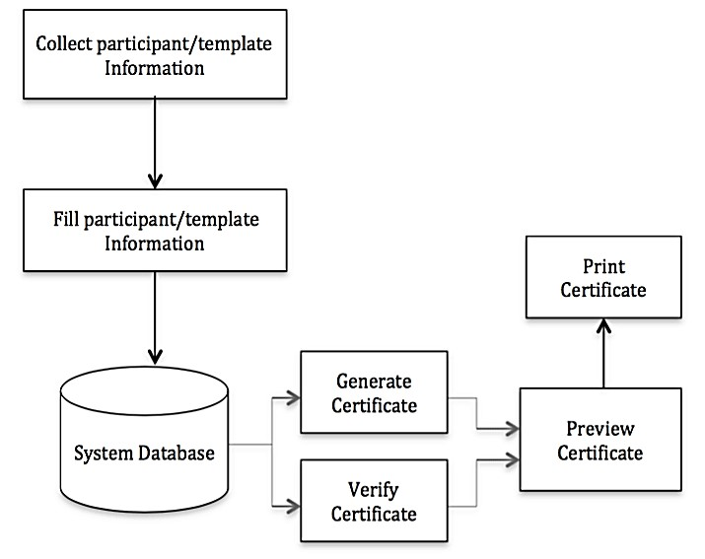

Figure 3.2: System Architecture

## 3.6.3 Database Tables/Queries Structures

The database is used to store all information that pertain the certificate records. The certificates information is static; this implies that once the certificate is generated and stored into the database, modification to them becomes impossible except when the need arises as authorized by the admin of the system. Below are the database table for the new system

**Table 1: Admin Details**

**Top of Form**

| **Name** | **Type** | **Extra** |
| --- | --- | --- |
| **id Primary** | int(11 | AUTO_INCREMENT |
| **Name** | varchar(50) |  |
| **Department** | varchar(255) |  |
| **EmailId Index** | varchar(50) |  |
| **MobNo** | bigint(11) |  |
| **Password** | varchar(50) |  |

**Table 2: Certificate Records**

Top of Form

| **Name** | **Type** | **Extra** |
| --- | --- | --- |
| id Primary | int(11) | AUTO_INCREMENT |
| Student_id | varchar(250) |  |
| qrcode | varchar(250) |  |
| Date | Timestap() |  |

Bottom of Form

**Table 3: Student Details**

Top of Form

| **Name** | **Type** | **Extra** |
| --- | --- | --- |
| id Primary | int(11) | AUTO_INCREMENT |
| Studentid Index | varchar(250) |  |
| Studentname | varchar(250) |  |
| Age | varchar(250) |  |
| Gender | varchar(250) |  |
| Level | Vacrchar(250) |  |
| Department | varchar(255) |  |
| image | varchar(255) |  |

Bottom of Form

## 3.6.4 Entity Relationship Modelling

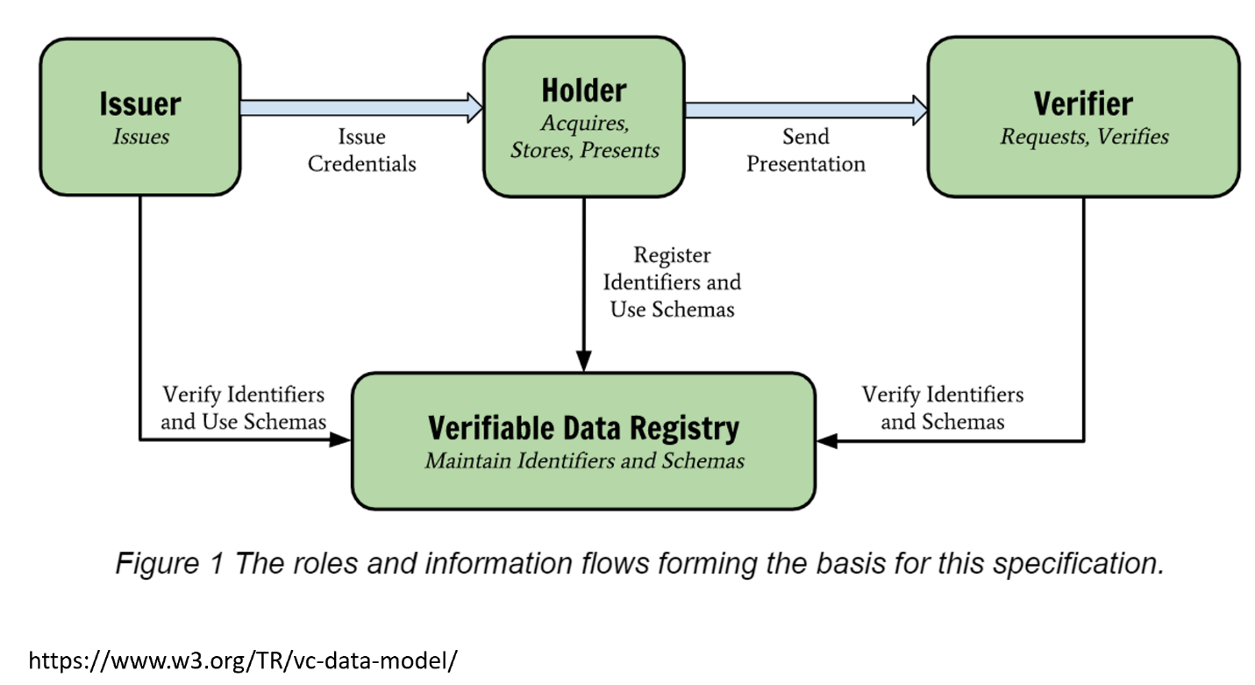

Figure 3.3: Entity Relationship Modelling

## 3.6.5 Database Entity Relationship Diagram

## 

Figure 3.4: Entity Relationship Diagram

## 3.6.6 Input and Output Design

**REGISTRATION**

Registration Number

Age

Department

**REGISTER**

Full Name

Level

Gender

Figure 3.5: Registration Form

**LOGIN**

**LOGIN**

**LOGIN**

Figure 3.6: Login form

**SCAN QR CODE**

REGISTRATION NUMBER

Figure 3.7: Scan QR Code

**GENERATE QR CODE**

REGISTRATION NUMBER

**GENERATE**

Figure 3.8: Generate QR Code

## 

| **Cert Code** | **Surname** | **Registration Number** | **Grade** | **Department** | **Year Graduated** | **Certificate Status** |
| --- | --- | --- | --- | --- | --- | --- |
| FPM/2023IFN5CX2RWD | GUBEH AOND MERMBEE | ST/CS/HND/21/037 | UPPER CREDIT | COMPUTER SCIENCE | 2023-08-24 | CERTIFICATE VERIFIED |

Figure 3:9: Report of a Verified Certificate

| **Surname** | **First Name** | **Last Name** | **Registration Number** | **Grade** | **School** | **Department** | **Year** |
| --- | --- | --- | --- | --- | --- | --- | --- |
| WASINDA | EMMANUEL | DAUDA | ST/CS/ND/20/364 | UPPER CREDIT | Science Technology | COMPUTER SCIENCE | 2023-08-03 |
| ABDUL | GODWIN | AUDU | ST/CS/HND/21/030 | DISTINCTION | Science Technology | COMPUTER SCIENCE | 2023-08-24 |

Figure 3:10: Records of all Certificate

## 3.6.7 Report Layout

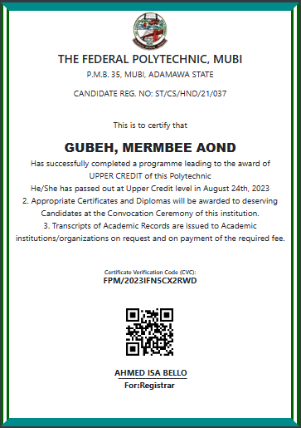

Figure 3.11: Generated Certificate with QR code

## 3.7 System Requirement Specification

## 3.7.1 Hardware Requirements

The software to be design needs the following hardware for an effective operation of the newly designed system.

1. A system running on intel, P(R) duo core with higher processor
2. The-Random Access Memory (RAM) should be at least 512MB.
3. At least 20-GB hard disk.
4. A monitor.

## 3.7.2 Software Requirements

The software requirements include:

1. A window 7 or higher version of operating system.
2. XAMP or WAMP for Database
3. PHP
4. MySQL
5. Browser

## 3.7.3 Personnel Requirement

Any computer literate who has a technical knowhow of internet surfing can use the system because it is user friendly.

# CHAPTER FOUR

# RESULTS AND DISCUSSION

## 4.1 Introduction

The new system is designed using PHP and MySQL programming language for easy records inserting and updating. This system will help in managing and easily retrieving of information from the system for management purposes. The Certificate Verification system using Quick Response code with aid the process of verifying academic certifications with less stress and time and also, reduce human efforts.

## 4.2 Results

## 4.2.1 Login Interface

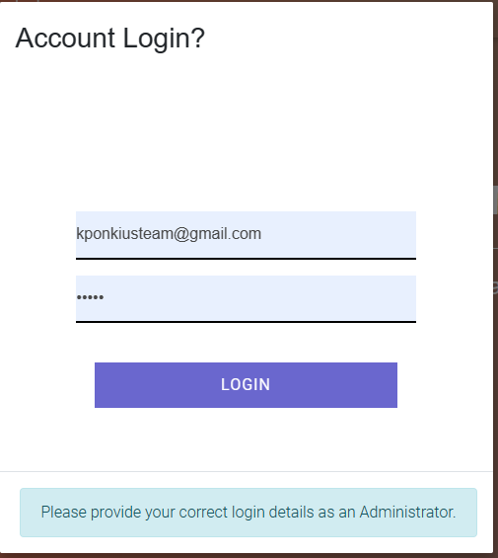

Figure 4.1: Login interface

Figure 4.1 above shows the system login page interface. The login interface allows the Administrator to enter his username and password to get access to the system. This section prevents or guides against unauthorized access into the system.

## 4.2.2 Admin Dashboard



Figure 4.2: Admin Dashboard

Figure 4.2 above shows the system admin dashboard interface. The dashboard interface shows all the tasks that can be performed by the Administrator such as register student, generate certificate and generate a QR code, update records, etc.

## 4.2.3 Add Certificate Interface

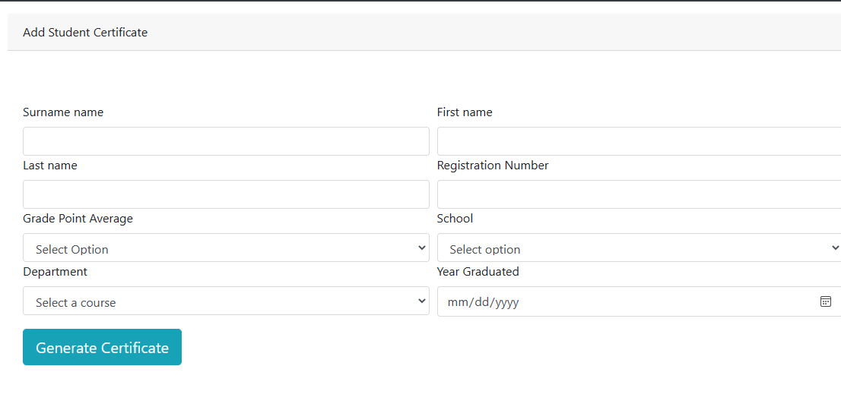

Figure 4.3: Add Certificate Interface

Figure 4.3 above shows where certificate can be generated or added into the system to enable the printing and verification of the certificate.

## 4.2.4 Generate QR Code Interface

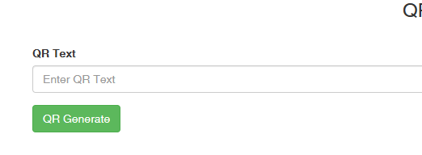

Figure 4.4: Generate QR code Interface

Figure 4.4 the above section is used to generate a unique QR code for a particular certificate that has been generated.

## 4.2.5 Certificate Records Interface

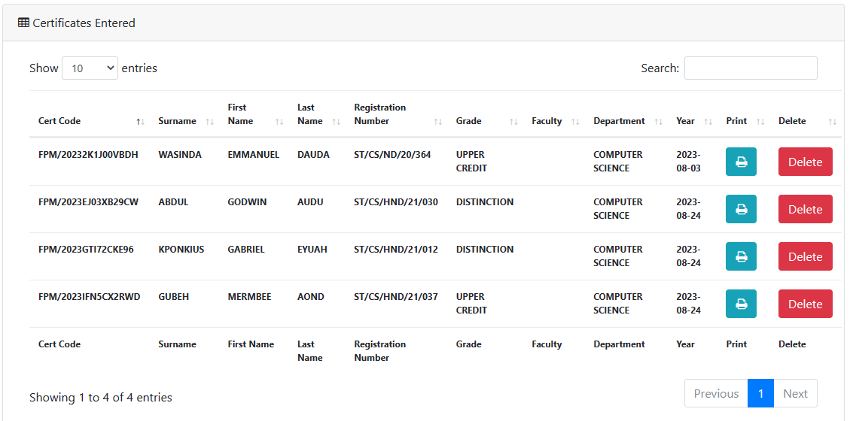

Figure 4.5: Certificate Records Interface

Figure 4.5 above displays all the certificate records generated with their unique QR code and certificate code, showing the name of the student, course, school, year of graduation and grade.

## 4.2.6 Certificate Interface



Figure 4.6: Certificate Interface

Figure 4.6 above shows the generated certificate with information of the owner and the certificate code and QR code of the certificate for verification purpose.

## 4.2.7 Verification interface

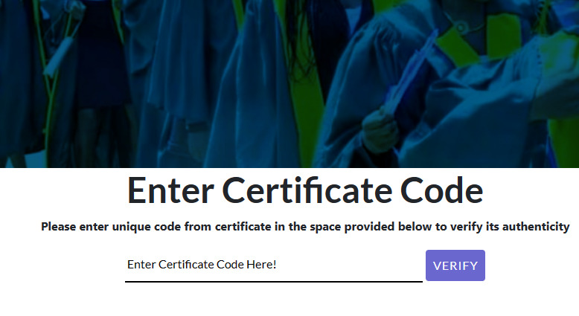

Figure 4.7: Verification Interface

Figure 4.7 above shows the verification interface of a certificate using the certificate code that is printed on the certificate.

## 4.2.8 Verification Result Interface

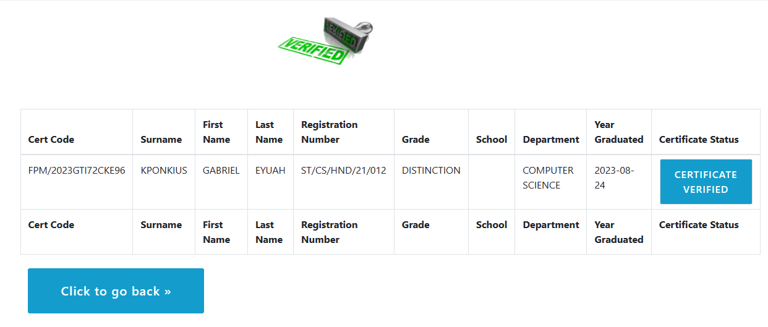

Figure 4.8: Verification Result Interface

Figure 4.8 above shows the result of a verified certificate using the certificate code on the certificate displaying the information to the ownership of a certificate code entered.

## 4.3 Discussion

Login Interface: This is the entry point for users, where they provide their credentials (such as username and password) to access the certificate verification system. It ensures that only authorized individuals can use the system.

Admin Dashboard: After logging in, administrators are directed to the admin dashboard. This section provides an overview of the system's functionality and allows administrators to manage users, certificates, and verification records.

Add Certificate Interface: This part of the system enables administrators to upload and input information related to certificates that need to be verified. They may provide details like certificate numbers, issuance dates, and associated individuals or organizations.

Certificate Records Interface: In this section, administrators can view and manage the records of all certificates stored in the system. It provides a comprehensive list of certificates with their details, allowing for easy tracking and retrieval.

Certificate Interface: This is the view where users (typically certificate recipients) can access and view their individual certificates. They may also be able to download or print them for reference or verification purposes.

Verification Interface: This interface is designed for individuals or organizations that want to verify the authenticity of a certificate. Users can scan a QR code or input a certificate number to initiate the verification process.

Verification Result Interface: After scanning the QR code or inputting the certificate number, users are presented with the verification result. This section informs them whether the certificate is genuine or fraudulent and may provide additional details about the certificate's issuer and validity.

These sections collectively form a comprehensive Certificate Verification System using QR codes, ensuring the security and authenticity of certificates while providing a user-friendly interface for both administrators and certificate recipients.

## 4.4 User manual

The following are the necessary steps to take in order to use the system efficiently and effectively.

1. Load the url of the system <https://localhost/certdev/> the welcome page will be displayed.
2. Click on the **Proceed** button to proceed to the main system.
3. If you created an account, provide your login details by entering your username and password.
4. Depending on the login details provided you will be automatically directed to the dashboard.
5. The various task that you can perform on the portal will be displayed on the sidebar of the dashboard.

# CHAPTER FIVE

# SUMMARY, CONCLUSION AND RECOMMENDATIONS

## 5.1 Summary

In this chapter, we provide a comprehensive summary of the design and implementation of a Certificate Verification System using QR code. Throughout this study, we have explored the various aspects of creating a secure and efficient system for verifying certificates using QR codes. This chapter summarizes the key findings, conclusions, and recommendations based on our research and implementation. In summary, it is the main objective of the system to provide an easy to use application that acts like a personal assistant by providing employer with an optimally planned schedule and easy confirmation of certificates. To optimize process taking into account various user constraints as well as other information like location of activities, their duration, and travel signal strength depending on mode of internet connectivity. Provide flexibility by offering to reload to accommodate any eventuality, provide access to user anytime and anywhere and linked to the central server and also, provide a web interface and/or other application.

## 5.2 Conclusion

In conclusion, the implementation of the Certificate Verification System using QR code brings forth a modern and efficient solution for Verifying academic certificates in Federal Polytechnic, Mubi. The various interfaces, certificate generation, QR code generation, unique, certificate code and printing, collectively contribute to a comprehensive and integrated certificate verification process. By digitizing and automating these processes, the system enhances accuracy, reduces manual efforts, and forgery of academic certificates and provides both institutions and employers with a convenient and effective means of engagement. The successful deployment of this system demonstrates its potential to revolutionize the way of verifying certificates, improving overall efficiency and ensuring the authenticity of academic certificates.

## 5.3 Recommendations

1. While the Certificate Verification System has proven to be effective, there is room for improvement and expansion. Based on our research and implementation, we recommend the following:
2. Continuous monitoring and updating of the system to stay ahead of potential security threats.
3. Integration with blockchain technology to enhance certificate immutability and transparency.
4. Collaboration with educational institutions, government agencies, and organizations to encourage widespread adoption.
5. Development of a mobile application for easier and more accessible certificate verification.
6. Implementation of multi-factor authentication for added security.

## 5.4 Contribution to Knowledge

This research and implementation have contributed to the existing knowledge in the field of certificate verification and QR code technology. Our contributions include:

1. A comprehensive design and implementation of a secure Certificate Verification System using QR codes.
2. Insights into the advantages and challenges of using QR codes for certificate verification.
3. A model for enhancing security and user-friendliness in certificate verification systems.
4. A framework for future research and development in the field of certificate verification technology.

## 5.5 Area for Further Work

While this study has achieved its objectives, there are several areas for further research and improvement:

1. Integration of biometric authentication for enhanced security.
2. Exploration of machine learning algorithms for fraud detection.
3. Development of a standardized format for QR codes in certificate verification.
4. Investigating the scalability of the system for large-scale deployment.
5. Conducting user experience studies to fine-tune the system's usability.

# REFERENCES

Abolaji, O.T. (2017). CIT 333 Software Engineering 1: *Course material, National Open University of Nigeria*. Retrieved from http://www.nou.edu.ng/sites/default/files/2017-03/CIT333.pdf

Adams, M. & Blandford, N. (2012). An academic certification verification system based on cloud computing environment. *International Journal of Machine Learning and Cybernetics*, 3(1), 55-88.

Boukar, M., Yusuf, S. & Muslu, I. (2017). A Web Service Based Database access for Nigerian Universities. *Certificate Verification System*, 45(2).

Chandrasekaran, A., & Suthanthira, A. (2017). Acceptability of medical digital libraries. *Health Informatics Journal*, 8(2), 58-66. Adams, A., & Blandford, A. (2004).

Furnell, S., & Warren, M. (2018). *Computer and information security handbook*. Elsevier Press, New York.

GeeksforGeeks (2018, November 20). Software Engineering: *System Design Strategy*. Retrieved from <file:///C:/Users/uncle%20kenn/Desktop/Project%20File/Cert.%20> Verification/CertVeri%20PDFs/TopDown%20Structure/Software%20Engineering%20_%20System%20Design%20Strategy%20-%20GeeksforGeeks.html

Hampo, A.J. (2011). *Design and Implementation of Student Verification System*. Retrieved from https://www.academia.edu/5135050.

Hashemi, S. S., Asadi, S., & Jantan, A. H. (2017). A survey on secure and efficient data aggregation in wireless sensor networks. *Journal of Network and Computer Applications*, 86, 1-21.

Hsu, C. W., Lai, C. H., Hsu, C. S., & Chung, Y. J. (2022). Secure and efficient QR code-based certificate verification system. *Journal of Visual Communication and Image Representation*, 81, 103019.

Hu, J., Wei, Q., Yu, C., & Hu, X. (2021). A lightweight certificate verification system using QR codes for e-commerce. *IEEE Access*, 9, 119729-119739.

Kshetri, N., & Voas, J. (2022). A trustworthy certificate verification system using QR codes for Internet of Things (IoT) devices. *Journal of Systems and Software*, 186, 110910.

Li, Y., Wang, Z., & Liu, Y. (2021). A machine learning-based certificate verification system using image recognition techniques. *International Journal of Machine Learning and Cybernetics*, 12(4), 895-907.

Musee, D. (2015). Scientific Representation of Nanotechnology. *Journal of Applied Physics*, 10(3), 27-38.

Nwachukwu, K.C.& Igbajar, A. (2015). Designing an Automatic Web-Based Certificate Verification System for Institutions. *Journal of Multidisciplinary Engineering Science and Technology,* 2(12), 3159-0040.

Osman, G. & Omar, S.S. (2016). Cloud-Based Graduation Certificate Verification Model. *Proceedings of Academics World 54th International Conference, Malacca, Malaysia.*

Park, J., & Kim, H. (2020). Secure QR code-based authentication scheme for mobile devices. *International Journal of Distributed Sensor Networks*, 16(8), 1550147720946684.

Rahim, N. A., Hashim, N. M., Ariff, M. F. M., Yusoff, N. M., & Ahmad, N. H. (2020). QR code-based certificate verification system for academic qualification. *Indonesian Journal of Electrical Engineering and Computer Science*, 17(2), 838-845.

Singhal, A., and Pavithr. R.S. (2015). Degree Certificate Authentication using QR Code and Smartphone. *International Journal of Computer Applications*, 120(16), 0975–8887.

Smartsheet, L. (2019). The limits of transparency: Pitfalls and potential of using QR codes in museums. Curator: *The Museum Journal*, 60(4), 417-430.

Srushti, A.S., Sanket, M., Aman, T., & Tyagraj, S. (2014). Certificate Generation System. *International Journal on Recent and Innovation Trends in Computing and Communication*, 2(2), 380 – 383.

Stallings, W. (2017). *Cryptography and network security:* Principles and practice (7th ed.). Pearson.

Tang, R., Su, Z., Chen, J., Wang, S., & He, Y. (2021). QR code design with visual aesthetics and error correction capability for reliable and attractive mobile interaction. *Journal of Visual Communication and Image Representation*, 75, 103-108.

Thampi, S. M., & Saxena, A. (2018). An efficient and secure certificateless signature scheme preserving unforgeability and data integrity. *International Journal of Network Security*, 20(1), 94-102.

Tint, S.S. & Win, H.H. (2014). Electronic Certificates in E-Learning System. *International Journal of Innovative Research in Science, Engineering and Technology*, 3 (9), 16049-16054.

Wachirawutthichai, K., Nukoolkit, C., & Wongwises, S. (2022). Secure and efficient QR code authentication protocol for e-commerce using the elliptic curve cryptosystem. *Sustainable Cities and Society,* 91, 111087.

Wang, J., & Li, M. (2023). Design and implementation of a certificate verification system using QR codes in higher education. *Journal of Educational Technology Development and Exchange*, 16(1), 78-92.

Wang, M. C., & Liao, S. Y. (2021). Design and implementation of blockchain-based certificate verification system. *Journal of Computational Science*, 55, 101352.

Warasart, M., and Kuacharoen, P. (2012). Paper-based Document Authentication using Digital Signature and QR Code. *International Conference on Computer Engineering and Technology,* 7(1),2674-27243

Wu, Y., Zhou, S., & Zhang, S. (2021). A survey on security and privacy of QR code-based applications. *Computer Networks,* 195, 108082.

Yang, H., Yu, J., Jiang, H., & Li, Q. (2023). A dynamic QR code generation approach based on evolving neural network for secure mobile interactions. *Information Sciences*, 578, 15-30.

# APPENDIX A

**Login Interface**



**Admin Dashboard**



**Add Certificate Interface**



**Generate QR Code Interface**



**Certificate Records Interface**



**Verification interface**



**Verification Result Interface**



**Certificate Interface**



**APPENDIX B**

**PROGRAM CODE**

<!DOCTYPE html>

<html lang="en">

<head>

  <meta charset="utf-8">

  <meta http-equiv="X-UA-Compatible" content="IE=edge">

  <meta name="viewport" content="width=device-width, initial-scale=1, shrink-to-fit=no">

  <meta name="description" content="">

  <meta name="author" content="">

  <title>The Federal Polytechnic, Mubi| Admin Dashboard</title>

  <link rel="shortcut icon" href="images/logo.jpg" type="image/x-icon">

  <!-- Bootstrap core CSS -->

  <link href="vendor/bootstrap/css/bootstrap.min.css" rel="stylesheet">

  <!-- Custom fonts for this template -->

  <link href="vendor/font-awesome/css/font-awesome.min.css" rel="stylesheet" type="text/css">

  <!-- Plugin CSS -->

  <link href="vendor/datatables/dataTables.bootstrap4.css" rel="stylesheet">

  <!-- Custom styles for this template -->

  <link href="css/sb-admin.css" rel="stylesheet">

  <!-- Your custom styles (optional) -->

  <link rel="stylesheet" href="css/style.css">

  <script type="text/javascript" src="../js/printer.js"></script>

  <style>

    .error {

      color: #D8000C;

      background-color: #FFBABA;

      width: 100%;

      border-radius: 5px;

      padding: 10px;

      margin: 20px;

    }

    .error-border {

      border: 1px solid red;

    }

  </style>

</head>

<body class="fixed-nav sticky-footer bg-dark" id="page-top">

  <!-- Navigation -->

  <nav class="navbar navbar-expand-lg navbar-dark bg-dark fixed-top" id="mainNav">

    <a class="navbar-brand" href="index.php">The Federal Polytechnic, Mubi</a>

    <button class="navbar-toggler navbar-toggler-right" type="button" data-toggle="collapse" data-target="#navbarResponsive" aria-controls="navbarResponsive" aria-expanded="false" aria-label="Toggle navigation">

      <span class="navbar-toggler-icon"></span>

    </button>

    <div class="collapse navbar-collapse" id="navbarResponsive">

      <ul class="navbar-nav navbar-sidenav" id="exampleAccordion">

        <li class="nav-item active" data-toggle="tooltip" data-placement="right" title="Dashboard">

          <a class="nav-link" href="index.php">

            <i class="fa fa-fw fa-dashboard"></i>

            <span class="nav-link-text">

              Dashboard</span>

          </a>

        </li>

        <li class="nav-item" data-toggle="tooltip" data-placement="left" title="Components">

          <a class="nav-link btn btn-default" data-toggle="collapse" href="#collapseComponents" data-parent="#exampleAccordion">

            <i class="fa fa-fw fa-user"></i>

            <span class="nav-link-text">

              Manage Admin</span>

          </a>

          <ul class="sidenav-second-level collapse" id="collapseComponents">

            <li>

              <a href="view_all_admin.php">View Admin</a>

            </li>

            <li>

              <a href="create_admin.php">Add Admin</a>

            </li>

            <li>

              <a href="edit_admin.php"> Edit Profile</a>

            </li>

          </ul>

        </li>

        <li class="nav-item" data-toggle="tooltip" data-placement="left" title="Example Pages">

          <a class="nav-link collapsed btn btn-default" data-toggle="collapse" href="#collapseExamplePages" data-parent="#exampleAccordion">

            <i class="fa fa-fw fa-certificate"></i>

            <span class="nav-link-text">

              Manage Certificate</span>

          </a>

          <ul class="sidenav-second-level collapse" id="collapseExamplePages">

            <li>

              <a href="addcertificate.php">Create Certificate</a>

            </li>

            <li>

              <a href="students.php">View Certificates</a>

            </li>

            <li>

              <a href="qr-code/index.php">Generate QR code</a>

            </li>

          </ul>

        </li>

      </ul>

      <ul class="navbar-nav sidenav-toggler">

        <li class="nav-item">

          <a class="nav-link text-center" id="sidenavToggler">

            <i class="fa fa-fw fa-angle-left"></i>

          </a>

        </li>

      </ul>

      <ul class="navbar-nav ml-auto">

        <li class="nav-item dropdown">

          <a class="" href="#" id="messagesDropdown" data-toggle="dropdown" aria-haspopup="true" aria-expanded="false" >

            <span class="d-lg-none">

              <span class="badge badge-pill badge-primary"></span>

            </span>

            </span>

          </a>

        <li class="">

          <a class="" href="#" id="alertsDropdown" data-toggle="dropdown" aria-haspopup="true" aria-expanded="false">

            <i class=""></i>

            <span class="d-lg-none">

              <span class=""></span>

            </span>

            <span class="new-indicator text-warning d-none d-lg-block">

              <i class=""></i>

              <span class="number"></span>

            </span>

          </a>

          <div class="dropdown-menu" aria-labelledby="alertsDropdown">

            <h6 class="dropdown-header"></h6>

            <div class="dropdown-divider"></div>

            <a class="dropdown-item" href="#">

              <span class="text-success">

                <strong>

                </strong>

              </span>

              <span class="small float-right text-muted"></span>

            </a>

            <div class="dropdown-divider"></div>

            <a class="dropdown-item" href="#">

              <span class="text-danger">

                <strong>

                  <i class="fa fa-long-arrow-down"></i>

                  Status Update</strong>

              </span>

              <span class="small float-right text-muted">11:21 AM</span>

              <div class="dropdown-message small">This is an automated server response message. All systems are online.</div>

            </a>

            <div class="dropdown-divider"></div>

            <a class="dropdown-item" href="#">

              <span class="text-success">

                <strong>

                  <i class="fa fa-long-arrow-up"></i>

                  Status Update</strong>

              </span>

              <span class="small float-right text-muted">11:21 AM</span>

              <div class="dropdown-message small">This is an automated server response message. All systems are online.</div>

            </a>

            <div class="dropdown-divider"></div>

            <a class="dropdown-item small" href="#">

              View all alerts

            </a>

          </div>

        </li>

        <li class="nav-item">

          <a class="nav-link" data-toggle="modal" data-target="#exampleModal">

            <i class="fa fa-fw fa-sign-out"></i>

            Logout</a>

        </li>

      </ul>

    </div>

  </nav>

<!-- Breadcrumbs -->

<div class="container align-items-center">

  <div id="print">

    <div id="cert" style="text-align: center; font-size: 20px;">

      <style type="text/css">

        #cert {

          position: relative;

          margin: 0 auto;

          border-style: solid double;

          border-color: darkcyan darkgreen;

          border-width: 20px;

          height: 270mm;

          width: 190mm;

          background: white;

          align-items: center;

        }

      </style>

    <a href="#"><img src="images/logo.jpg" alt="GOUNI-LOGO" height="100"></a>

    <h3>THE FEDERAL POLYTECHNIC, MUBI</h3>

    <p>P.M.B. 35, MUBI, ADAMAWA STATE</p>

    <span><p style="position:absolute; justify-content: center; text-align:left;"></p>CANDIDATE REG. NO: ST/CS/HND/21/030</p>

    <br>

    <p>This is to certify that</p>

    <span style="font-size: 30px; font-family: 'arial black', sans-serif; text-transform: uppercase;">

        ABDUL, GODWIN AUDU    </span>

    <br>

    <span>Has successfully completed a programme leading to the award of</span>

    <br>

    <span style="font-size: 20px; text-transform: uppercase;">Distinction</span>

    <span>of this Polytechnic</span>

    <br>

    <span style="font-size: 20px;">

        He/She has passed out at Distinction level in August 24th, 2023    </span>

    <span>

        <br>

        2. Appropriate Certificates and Diplomas will be awarded to deserving Candidates at the Convocation Ceremony of this institution.

        <br>

        3. Transcripts of Academic Records are issued to Academic institutions/organizations on request and on payment of the required fee.

    </span>

    <br>

    <br>

    <br>

        <h4 style="text-align: center; font-size: 14px;">Certificate Verification Code (CVC): <br><span style="font-weight: bold; font-size:20px; text-transform:uppercase;">FPM/2023EJ03XB29CW </span></h4><br>

        <img src='qr-code/images/1692903245.png'  alt='' height='150' width='150' >        <br>

        <br>

        <p style="position:absolute; right: 250px; top: 855px; text-align:center; font-weight: bolder;">AHMED ISA BELLO</p> <br>

        <p style="position:absolute; right: 250px; top: 860px; text-align:center; font-weight: bolder;">____________________</p> <br>

        <p style="position:absolute; right: 280px; top: 885px; font-weight: bolder;">For:Registrar</p>

    </div>

  </div>

</div>

<div class="alert">

  <div class="alert alert-success">

    <p class='text-center'>Certificate has been Generated Successfully <span class="btn btn-primary" class="btn btn-default " onclick="printDiv('print')"> Print Certificate</span></p>

  </div>

</div>

<script>

  function printDiv(divName) {

    var printContents = document.getElementById(divName).innerHTML;

    var originalContents = document.body.innerHTML;

    document.body.innerHTML = printContents;

    divName.print();

    document.body.innerHTML = originalContents;

  }

</script>

<section>

    <div class="sticky-footer">

        <div class="container">

            <div class="text-center" style="position: relative; top: 20px;color: white; ">

                <p>© Copyright 2020 The Federal Polytechnic, Mubi  - All Rights Reserved Design and Developed by: KponkiusDev Team.

                </p>

            </div>

        </div>

    </div>

</section>

    <!-- Scroll to Top Button -->

    <a class="scroll-to-top rounded" href="#page-top">

      <i class="fa fa-angle-up"></i>

    </a>

    <!-- Logout Modal -->

    <div class="modal fade" id="exampleModal" tabindex="-1" role="dialog" aria-labelledby="exampleModalLabel" aria-hidden="true">

      <div class="modal-dialog" role="document">

        <div class="modal-content">

          <div class="modal-header">

            <h5 class="modal-title" id="exampleModalLabel">Account Logout?</h5>

            <button type="button" class="close" data-dismiss="modal" aria-label="Close">

              <span aria-hidden="true"><i class="fa fa-close"></i></span>

            </button>

          </div>

          <div class="modal-body">

           <p class="alert alert-info text-center"> Are you Sure you want to Logout from this Account?</p>

          </div>

          <div class="modal-footer">

            <button type="button" class="btn btn-danger btn-lg" data-dismiss="modal">No</button>

            <a class="btn btn-primary btn-lg" href="includes/logout.php">Yes</a>

          </div>

        </div>

      </div>

    </div>

    <!-- Bootstrap core JavaScript -->

    <script src="vendor/jquery/jquery.min.js"></script>

    <script src="vendor/popper/popper.min.js"></script>

    <script src="vendor/bootstrap/js/bootstrap.min.js"></script>

    <!-- Plugin JavaScript -->

    <script src="vendor/jquery-easing/jquery.easing.min.js"></script>

    <script src="vendor/chart.js/Chart.min.js"></script>

    <script src="vendor/datatables/jquery.dataTables.js"></script>

    <script src="vendor/datatables/dataTables.bootstrap4.js"></script>

    <!-- Custom scripts for this template -->

    <script src="js/sb-admin.min.js"></script>